Subliminal is that information accepted by your subconscious into the brain that bypasses conscious screening or awareness.
This absorption of information occurs indiscriminately:
NOW USING THIS TECHNOLOGY YOU ENGAGE CHANGE WITH DELIBERATE INTENT

Subconscious to conscious way of Learning - SCWL®

Subliminal Learning is a proven tool for behavioural modification-
SCWL® Subliminal programs have gained status with leading psychologists, physicians and professionals worldwide. Professional athletes and coaches are using SCWL® Subliminal Programs to boost performance and enhance mental abilities- corporations are playing SCWL® programs to reduce stress levels and motivate sales-people.

University research shows that students who play SCWL® Subliminal programs while studying score higher. Evidence backed by research and studies show the SCWL® programs are assisting a wide range of people with very positive results.

SCWL® Subliminal programs contain around 100,000 positive affirmations which are absorbed by your subconscious mind each hour the program is played. Each SCWL® program is a pleasant highly effective positive self-promoting and effortless way to help achieve the personal goals set for yourself.

As the subliminal program is played all that is heard is the cover track of ocean waves and nature noises, soothing and relaxing, and this sound relaxes the conscious mind so your sub-conscious becomes more receptive. Working on the principle of repetition for each 10 hours of playing, an estimated 1 million positive suggestions are received by your sub-conscious mind setting up a new pattern of behaviour to produce improvement and positive change.

HOW DO I KNOW SCWL® IS SAFE TO USE?

In order to provide a technologically advanced product to enhance the human mind’s ability to improve the quality of thinking, we at MIDWEST RESEARCH of MICHIGAN we forged a plan for the development of both our organization and for the development of Subliminal Technology.

Each Subliminal program is overseen by a body of professionals who have combined to develop the scripting and technology arrived at for each title. Each program has been examined and certified for the message content by Midwest Research of Michigan and accordingly the undersigned professionals verify and certify that the message content is related to the stated purpose of the program.

Affirmations are positive in nature
Examination of the messages show no evidence of malevolent intent or content
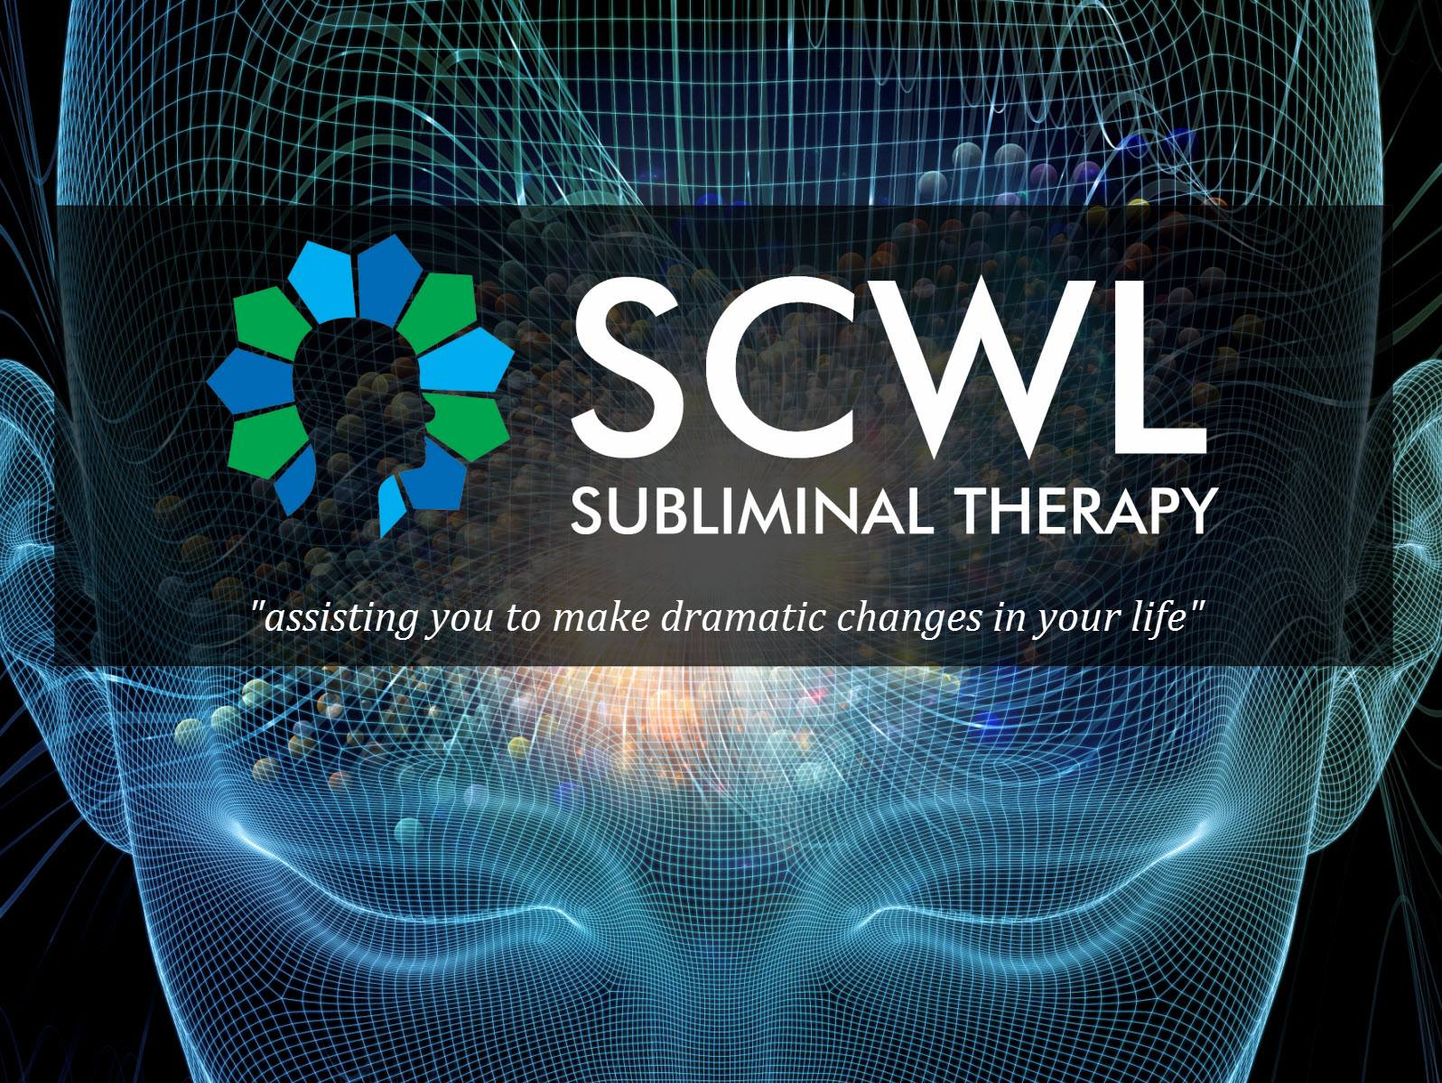
Examination of messages shows no evidence of cryptic or occult content and no evidence of political indoctrination.

CERTIFIERS:
Phillip A Hansen ED.D- California
Nate Greenstein D.C. Florida
Lawrence Sterne Ph.D New York
Esther M.Newlin-Haus Ph.D Tennessee
Shirley B Hansen Ed.D California
Nancy A. Reisman R.N.M.A. California
William F, Morton Ed.D Washington
George J. Haus Ph.D Tennessee
Give yourself 90 days to experience results- although most customers begin to experience change immediately. Play each program at least 1 hour a day. After 90 days the company suggests that you will have undergone a change in degree. Factors outside this generality may influence the degree that change may occur, however never put a time limit on your rate of change.

Dedicated to Improving the Quality of Life

WHAT YOU NEED TO DO IS SET GOALS:

Our brain is a goal seeking mechanism- it must have goals. Yet numerous studies indicate less than 5% of all persons have a written set of goals and future plans. Yet our brains need these goals. By setting goals we focus our thoughts toward a target or one desired end result and in this way push our subconscious toward that focus like a magnet.

Everything on this earth has its equal and opposite; we live in the universe, yet there is a vast universe within us and although we live in consciousness or awareness, we are directed by the information we have allowed and accepted into our subconscious. The ability of the subconscious mind is unlimited but handling one hundred million messages every second is its job. Imagine harnessing this truly miraculous communication network.

Most of us do not have clear goals and by DEFAULT our brain selects goals from our dominant thoughts.

These default goals enable the R.A.S Reticular Activating System to effectively filter out those 100 million pieces of information coming into our brain at a deeper level of consciousness. By writing and visualizing your goals, you replace default goals with new and precise and powerful end result to guide and create your own life purposefully.

The Power of Subliminal Messages

We all want to change something in our lives and in ourselves. Whether you want to lose weight, gain confidence, stop smoking, or start exercising, there’s some mountain in your life you’d like to move. You can change the way you think, feel, behave and respond!

The SCWL® subliminal programs accelerate goal achievement and utilize the goal-seeking tendencies of the mind in three ways:
- By stimulating healthy motivated tendencies already present-Each of us has a natural way of relating and responding to experiences in our world- Subliminal programs build on these natural responses.

- By putting in positive information in our brain, bypassing our mental blocks, negative tendencies or limitations- Consciously our thoughts can create barriers- subliminal input by-passes thoughts and directs new information to overcome the impact of conscious thinking.

- By relaxing the listener allowing faster learning and recall. The surface layer of ocean waves achieves relaxation and is calming to most customers.
The SCWL® subliminal programs are today’s ideal motivation tools to help you expand your thinking and alter or change beliefs in your abilities.

Dr David Murphy, orders@scwl.org,
Midwest Research SCWL, Australasia,
Est 1984, ph 8214 8397, 0419 605 365.
Product Information Website: scwl.org

SCWL SUBLIMINAL PROGRAMS DELIVERED ON CD'S

1 Weight Loss/Control
2 Stop Smoking
3 Stress Control
4 Increase your Memory Power
5 The Best in You, Personality
6 Sex/Loving Relationships
7 Overcoming Fear and Worry
8 Overcoming Depression
9 The Joy of Life / Showing Your Happiness
10 Better Health through Positive Thinking
11 Success Motivation
12 Total Concentration
13 Overcoming Shyness
14 Stop Procrastination
15 Develop Your Creativity
16 Think Yourself to Greater Riches
17 Better Selling Skills
18 Superstar Performance for Athletes.
19 Mutual Sexual Satisfaction
20 Reversing Impotence
21 Deep Relaxation
22 Controlled Smoking
23 Insomnia, Proper Rest to Meet Full Potential
24 Alcoholism - Abstinence From Drinking
25 Alcoholism - Controlled Drinking
26 Get High on Life
27 Developing Your Psychic Abilities
28 Agoraphobia, Fear of Open Places
29 Claustrophobia, Fear of Being Closed In
30 Self Confidence
31 Elevate Self Image
32 Setting And Achieving Positive Goals
33 Unlimited Power of Positive Thinking
34 Sharpen Learning Skills
35 Improve Study Habits
36 Passing Exams with Flying Colours
37 Meditation
38 Grief - Dealing with the Loss of a Loved One
39 Calm Your Nerves, the Subliminal Tranquilizer
40 Exercising Patience and Understanding
41 Gaining Confidence with the Opposite Sex
42 Reversing Frigidity
43 Increased Vitality
44 Getting Into Exercise
45 Body Toning Through Mental Imagery
46 Achievement Through Physical Endurance
47 Developing A Winner's Attitude
48 Reaching the Top, Thinking and Being the Best
49 Golf - Visualize Your Game
50 Golf - Perfect Concentration
51 Bowling - the Approach
52 Bowling - the Release
53 Recruiting in MLM Confidently
54 Visualize Total Success in MLM
55 Creating Retail Sales in MLM
56 Setting and Achieving MLM Goals
57 Effective Speaking
58 Decision Making for Success
59 Speed Reading
60 Reading with Retention and Comprehension
61 Feeling Love Giving Love
62 Family Development through Love, Harmony and Respect
63 Personal Power Dynamics
64 Psychoneuroimmunological Healing:
the Beneficial Influence of the Mind on Health
65 Relieving Anxiety
66 Beginning Typing
67 Advanced Typing
68 Nail Biting
69 Organizing Your Time
70 Enthusiasm
71 Imagination, the Teacher Inside
72 Perfecting Tennis
73 Appetite Control
74 Maintaining Your Ideal Weight
75 Endurance Running
76 Effective Listening
77 Remembering Names
78 Safe Driving
79 Self Discipline
350 Control Baseball Pitching
352 Overcoming Paralysis
353 High Diving
356 Attitude & Performance Changes in Roller Skaters
363 Becoming a Football Champion
369 Flexibility - in thinking
371 Becoming a Basketball Champion
372 Conditioning Program
373 Acceptance Program
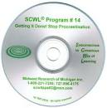
374 Coordination Program
376 The Healthy Skin Program
377 Expansion Program
378 Problem Solving
379 Language Learning
381 Darts
392 Control (Softball Pitching)
393 Fielding (Baseball)
394 Hitting (Baseball or Softball)
395 Trapshooting Singles
397 Perfecting the Musical Keyboard
401 Masculinity
402 Baseball's 400 Hitter
403 Desire and Purpose
404 Faith and Belief
405 Prosperity Consciousness
406 Trapshooting Doubles
408B Pain Relief
409 Lucid Dreaming
410 Total Health Development & Self Confidence
411 Cerebral Palsy (Stage 1)
412 Cerebral Palsy (Stage 2)
413 Cerebral Palsy (Stage 3)
414 Pre Natal Labour and Delivery
415 Golf - Mastering the Short Game
416 Enlightened Birth and New Life
419 Self Hypnosis
423 Femininity
425 Free of Harmful Drugs
426 Dental Care and Relaxation with the Dentist
428 Skeetshooting
430 Okinawan Karate
437 Astral Projection
450 Alzheimer's
451 Equestrian Riding Program
453 Setting and Achieving Real Estate Goals
454 Organization – Real Estate
455 Telephone Power – Real Estate
456 Referrals – Real Estate
457 Qualifying Buyers – Real Estate
458 Setting Appointments – Real Estate
459 Listing Homes That Sell – Real Estate
460 Closing Real Estate Deals – Real Estate
461 Prospecting for Leads – Real Estate
462 Leadership – Real Estate
463 Attracting Ideal Mates for Women
464 Attracting Ideal Mates for Men
467 Cerebral Palsy (Stage 4)
474 Faith and Victory
475 Health, Life and Spiritual Enrichment
476 Golf - Focusing on the Target
477 Bowling for Higher Average
478 Bowling - Focusing on the Target
479 Managing Insurance Salespeople
480 Recruiting New Agents
481 Total Insurance Success
484 Selling Insurance
487 Healing in the Name of Jesus Christ
491 Competitive Rowing
494 Subliminal Poker
495 Competitive Swimming
496 Running (Elite)
497 Total Control: The Willpower Program
499 Achieving Full Potential in Archery
502 Total Diet Control/Willpower Support Program
503 Competitive Cycling / Training
504 Competitive Cycling / Competition
505 Competitive Cycling / Healing and Recovery
509 The New Testament - KJV
511 I Can Say No to Harmful Drugs
512 Pre Natal Care: Mother and Baby
513 Labour and Delivery
514 Responding to Hypnosis
515 Hockey
517 Shooting Basketball
519 Pearl of Great Price
520 Doctrine and Covenants
523 Attracting Money
526 Achieving the Athletic Zone in Golf
529 Cocaine Abuse
530 New Weight Loss
1095 God's Affirmations
1114 God's Health and Healing
1119 Speak it! Spanish
1120 Speak it! French
For Children under 7:
1123: Confidence and Self
1124: Character and Personality
1125: Accelerated Learning
1130 Winning Numbers and Speculation
1151 Breast Enlargement
4127 Mastering Blackjack

- *Achieve behavioural change at the subconscious level, without effort, willpower or concentration.
- *SCWL Subliminal Programs for 1 to 3 are $75 each. For more than 3, programs for say a ‘personal library collection’, prices come down effectively to as low as half price, i.e. $37.50, in this way:
- Buy 3, get 1 more free. Buy 5, get 2 more free.
- Buy 7, get 3 more free. Buy 10, get 5 more free.
- Buy 15, get 10 more free Buy 20 get 20 more free.
- * 91 → 105 day money back guarantee on results.
- Pay by Paypal or to CBA account 062 145 10359877
- * Details for each title and 40 years of testimonials are available on request or at scwl.org
- * Multi CD carousel players for sequential play for enhanced results are recommended.
- * Why not run off a number of these sheets and ask friends etc to go through the list and see what interests them? In this way you can collectively secure the more price effective free cd offers.
- * It can be is daunting to look at the list and try to work out an order. A very effective and easy way to work out your order is to go through the list and cross out all the titles you are definitely not interested in, either for yourself or as gifts, so as to narrow down your selection.
- * Order from: Dr David Murphy, orders@scwl.org, Midwest Research SCWL, Australasia, Est 1984, ph 8214 8397, 0419 605 365. Agents' Support Website: scwl.org

Freelance agency enquiries welcome.
LETTER FROM THE COMPANY PRESIDENT:

Thank you for taking the time to enquire about SCWL® Subliminal Programs. Inside this catalog, you’ll learn about a scientifically proven product that has literally helped thousands of people enjoy a better and more productive life-style while accomplishing their most important goals. SCWL® is fascinating the way it works so effortlessly to create our desired results.

If I were to ask you what the most powerful thing on this earth was, would you say it was a thought? You’d be absolutely right! Everything that surrounds you was first a thought in someone’s mind, a chair, a plane, a pen, a computer, even a cup, were all first a thought. The most powerful ability each of us possess is the power of our own thinking... the power to create from thought, anything you can conceive and believe in.

The difference between people is directly related to the quality of their thinking.

It is to the quality of thinking that Midwest Research of Michigan, Inc. is dedicated.
You can change your life by changing your thinking. This concept is what all positive thinking books are telling us. If we desire a change in our life, we must do something that changes our thinking. Thinking is the conscious minds’ activity; however, it is completely influenced by our subconscious beliefs - beliefs that have often taken a lifetime to form.

If we sincerely desire a change in our life, we must alter what we believe about ourselves in our subconscious mind.

SCWL® subliminal programs will help you make those positive changes in your life. Join the millions of people around the world who have made dramatic changes in their lives with the help of SCWL® subliminal programs.

The subliminal programs contained on this site may well represent the most powerful tools for your self-improvement and personal development you have ever found.
By using subliminal programs presented here you can……..
- Use more of the power of your mind to improve any aspect of your life
- Reinforce and accelerate the achievement and realisation of your chosen goals
- Change self-limiting attitudes and beliefs into powerful internal motivation
- Accelerate learning ability - improve memory, concentration and problem solving, read faster and retain more
- Eliminate fear and worry, anxiety and depression. Bypass the limitations of your conscious mind where these self-limiting thoughts and doubts exist

Our SCWL subliminal programs replace negative thinking with carefully scripted positive affirmations that motivate you to move forward and improve fast

- You can develop a new sense of wellbeing on all levels developing skills and natural abilities from the inside out
- Improve your prosperity and ability to manifest money or opportunities
- Develop greater creativity, imagination and intuition
- Boost happiness and self esteem
- Improve health energy levels vitality and immune system
- Improve sex life, enhance loving relationships
- Eliminate unwanted HABITS- weight control, alcohol, nail biting drugs etc
- Improve decision making, self-discipline and goal achievement, eliminate procrastination strength willpower and confidence
- Improve musical ability, sporting ability talents and skills in business and marketing
- Harness the power of your subconscious mind ( the 95% below the surface)

Eliminate the need for determination, willpower, and sustained effort

These ‘no listening’ programs allow the messages to be received and stored without awareness. Thousands of positive affirmations reprogram your mental computer.

Make positive changes to any area of your life quickly and easily, using your mind power

It is a fantastic tool for self-development requiring little effort to get results.

Would like to improve your memory stop smoking, lose weight or be more relaxed?
All this is possible and much more by harnessing the remarkable power of your subconscious mind.

The SCWL subliminal programs in this catalogue use a highly sophisticated digital recording process with multiple tracks and ultra-sensitive tones and frequencies that contain thousands and thousands of carefully crafted totally positive affirmations which are accepted by and stored in your subconscious. Your brain soaks up the positive motivational statements like a dry sponge accepts water and in no time at all you become motivated and inspired to make positive changes in your life.

There is no need to listen attentively to these programs - this fantastic self-development tool requires little effort to get results.

ABOUT YOUR SUBCONSCIOUS

Our conscious and subconscious mind work together to allow us to grow, develop and create our life.
Every second, 100 million messages bombard the brain carrying information from the body’s senses.

How the Mind & Body Communicates
To understand how subliminal programs work, let us first take a look at how our body and mind communicate, and how our conscious and subconscious mind functions.
Scientific studies have proven that the human mind is an internal and an external sensory monitoring system, which functions electronically.

Internally, our entire bodily functions are controlled subconsciously and automatically through the nervous system including blood flow, digestion, and organ functioning, viral and infectious control-immune response, cell communication and healing response.

THE SUBCONSCIOUS MIND:
The subconscious mind is our data storage bank. When the conscious mind asks, our subconscious mind gives. The subconscious mind takes in everything we learn and experience in our lifetime.

It begins at conception, soaking up information like a sponge, accumulating information as we grow and experience life. It also begins forming beliefs based on what we learn and what we have been exposed too, which determines how we react to everything in our life. These beliefs gain both strength and momentum the older we become through attraction like a self fulfilling prophecy. THIS can now be changed and does not have to be an automatic unconscious response to life, out of our control.

The CONSCIOUS MIND:
Our conscious mind is our “awareness”, it is our communication centre. It thinks, reasons, calculates, plans, directs all actions of the body, determines results and makes decisions. It is creative, it registers pain and fear, happiness and it sets goals (both long-term and very short-term goals). The conscious mind makes choices, almost every minute of our lives. In order for the conscious mind to be able to do all of these things, it must have a place to pull information from- a storage area.

It is a matter of choice.

Since everything has its equal and opposite- this is a basic law of nature- such as day and night; love and hate; prosperity and poverty; our lives are a matter of choice, our conscious choices. All these choices are made with the information we have amassed in our subconscious mind over a lifetime: and these experiences set up our conditioning and the quality of our life.

The simple conclusion is that if we are dissatisfied with anything in our lives, we must do something that will work at adding, altering, or changing those beliefs in our subconscious mind….. For the quality of your life is DIRECTLY related to the quality of our thinking…..

HOW IT WORKS:

YOUR BRAIN CHOOSES GOALS FROM DOMINANT THOUGHTS

Our internal monitoring system is equipped to sense vibrations of light, touch, taste, smell, and sound through our sensory organs. The human body is connected to the mind-the R.A.S- Reticular Activating System or sensory monitoring system via the nervous system which flows from the spinal cord. Like a seed with wisdom or an animal with instinct, the body knows how to communicate with its controller. Massive communication and control are handled systematically and simultaneously by the subconscious mind, designed to keep us functioning perfectly.
The Reticular Activating System is the extra-ordinary sensory receptor part of the brain. It is the control centre which receives around 100 million pieces of information each second you are alive through your five senses.

A study of physics indicates that there is light at the centre of every atom and that there is movement on all substance. Movement creates a vibration; therefore the sense of touch is merely the picking up of a substances vibration and by electric impulse relaying it to the brain via the nervous system. For example: Our tongue is equipped with highly sensitive nerve endings that send taste sensations to the brain from anything tasted. Aromas given off are the movement within a substance that our nerve endings within our nose pick up and send via electrical impulse to the brain which makes an interpretation of the experience.

Likewise the retina of the eye, with its 126.3 million rods and cones (fibrous material) transmits light sensations to the brain by electric impulse through the optic nerve. The ear is also a sound vibration receiver and coverts the vibrated sound into electrical impulses and sends them to the brain.

THE IMPORTANCE OF THOUGHT:

During internal sensory monitoring our conscious mind is busy thinking no more than one thought at any point in time. When we think the same thought over and over these thoughts become the focus of our attention, the things we value in our life and this sets up our beliefs systems- belief systems are what causes our behaviour. BUT GUESS what?? Belief systems no matter how engrained can be changed. The SCWL® Subliminal programming system sets up new and better belief systems so that you can change those responses that you thought were permanent.

