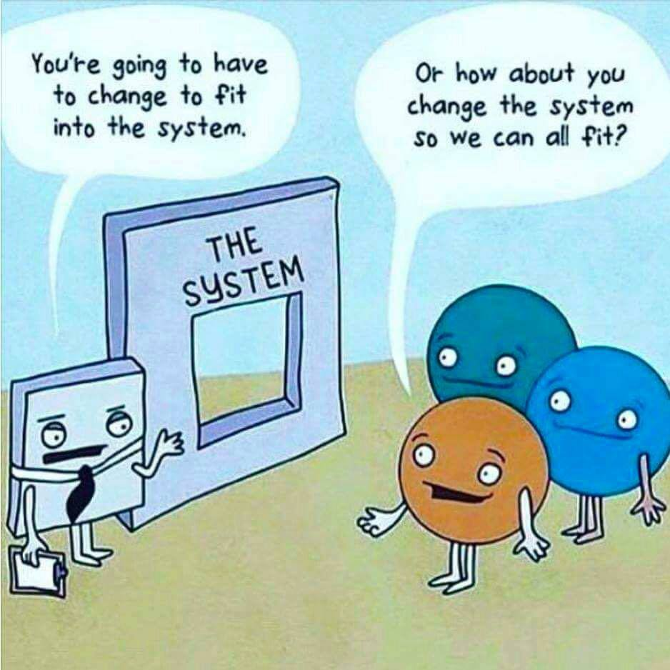
Hi ______

Here are the masters of the A3, A4 and A5 lists for you to substitute your name, your email and your contact number/s and be able to print off a week's requirements at a time.

Your initial target is to hand out 4 hours worth = say 400 per day, giving out, say, 2 to each person, 5 days per week.

Suggested wording is to quickly say upon giving out the A5's to each person: “Something that will change your life, please give me a call. I'll give you an extra one for a friend” and give them a big smile.

You will meet a lot of people and have a lot of very interesting conversations. Their questions will give the direction and foundation for your training.

Always be ready, if people want to chat or have questions, to break off and go for coffee by saying “If you like, let's go for coffee and talk about it all” and go for a 20 + 20 sale or lesser. Perhaps you will find half your time will be in giving out A5's and half having coffee sales meetings / dates!

Current commission on a 20+20 is $800.

The commission agents resource page for extra literature to have with you is up at http://users.tpg.com.au/matchdc/SCWLresources.html and more will be added soon.

Recommended script when people ring is something like this:

“Hello, I got this brochure.

And you found it of interest?

Yes, quite.

When you went through the list how many did you find of interest altogether?

Heaps.

How many say?

Heaps

Give me the numbers or titles and you should be able to get some free.

Get the numbers or titles and work out the deal and price.

We have an offer buy ??? and get ??? more free. Would you like to do that and get ??? more free?

Once payment is received into the account you have there the programs will be dispatched - so let's do that then shall we?

I need your name and postal address and contact number.

You will need to complete payment and when it comes up on Netbank we will dispatch.”

Of course this sounds too easy so be ready for absolutely all sorts of questions because they will have heaps of them just to see if you can win their purchase.

* Don't forget to get all contact details so so as to do follow up, if needs be, if some people are tardy in putting in payment for their order.

I do request that you keep some moving (running) daily, weekly and monthly spreadsheet statistics upon which you are ever aiming to improve.
For example: percentages you can work on are:
- the % of people who ring you back, aim to get your enquiry rate up to 20%,
- the % of those you convert to a sale, aim to get this up to 75%,
- the average number of cd's they buy - aim to get this up to about 6 to 15.
- income, aim to be earning over a very professional $2,000 to $6,000 per week over a moving 13 week average.

Always be on the lookout for those who would like to do what you are doing as these people will become part of your team and you will earn overrides two levels deep with infinite width.

A training will be held at Concord office soon.

Dr David Murphy
Midwest Research SCWL
8214 8397
0419 605 365

