MIDWEST RESEARCH - SCWL SUBLIMINAL COMPACT DISKS
1 Weight Loss/Control
2 Stop Smoking
3 Stress Control
4 Increase your Memory Power
5 The Best in You, Personality
6 Sex/Loving Relationships
7 Overcoming Fear and Worry
8 Overcoming Depression
9 The Joy of Life / Showing Your Happiness
10 Better Health through Positive Thinking
11 Success Motivation
12 Total Concentration
13 Overcoming Shyness
14 Stop Procrastination
15 Develop Your Creativity
16 Think Yourself to Greater Riches
17 Better Selling Skills
18 Superstar Performance for Athletes.
19 Mutual Sexual Satisfaction
20 Reversing Impotence
21 Deep Relaxation
22 Controlled Smoking
23 Insomnia, Proper Rest to Meet Full Potential
24 Alcoholism - Abstinence From Drinking
25 Alcoholism - Controlled Drinking
26 Get High on Life
27 Developing Your Psychic Abilities
28 Agoraphobia, Fear of Open Places
29 Claustrophobia, Fear of Being Closed In
30 Self Confidence
31 Elevate Self Image
32 Setting And Achieving Positive Goals
33 Unlimited Power of Positive Thinking
34 Sharpen Learning Skills
35 Improve Study Habits
36 Passing Exams with Flying Colours
37 Meditation
38 Grief - Dealing with the Loss of a Loved One
39 Calm Your Nerves, the Subliminal Tranquilizer
40 Exercising Patience and Understanding
41 Gaining Confidence with the Opposite Sex
42 Reversing Frigidity
43 Increased Vitality
44 Getting Into Exercise
45 Body Toning Through Mental Imagery
46 Achievement Through Physical Endurance
47 Developing A Winner's Attitude
48 Reaching the Top, Thinking and Being the Best
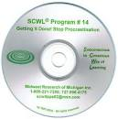
49 Golf - Visualize Your Game
50 Golf - Perfect Concentration
51 Bowling - the Approach
52 Bowling - the Release
53 Recruiting in MLM Confidently
54 Visualize Total Success in MLM
55 Creating Retail Sales in MLM
56 Setting and Achieving MLM Goals
57 Effective Speaking
58 Decision Making for Success
59 Speed Reading
60 Reading with Retention and Comprehension

61 Feeling Love Giving Love
62 Family Development through Love, Harmony and Respect
63 Personal Power Dynamics
64 Healing, Psychoneuroimmunology, the Beneficial Influence of the Mind on Health
65 Relieving Anxiety
66 Beginning Typing
67 Advanced Typing
68 Nail Biting
69 Organizing Your Time
70 Enthusiasm
71 Imagination, the Teacher Inside You
72 Perfecting Tennis
73 Appetite Control
74 Maintaining Your Ideal Weight
75 Endurance Running
76 Effective Listening
77 Remembering Names
78 Safe Driving
79 Self Discipline
350 Control Baseball Pitching
352 Overcoming Paralysis
353 High Diving
356 Attitude & Performance Changes in Roller Skaters
363 Becoming a Football Champion
369 Flexibility - in thinking
371 Becoming a Basketball Champion
372 Conditioning Program
373 Acceptance Program
374 Coordination Program
376 The Healthy Skin Program
377 Expansion Program
378 Problem Solving
379 Language Learning
381 Darts
392 Control (Softball Pitching)
393 Fielding (Baseball)
394 Hitting (Baseball or Softball)
395 Trapshooting Singles
397 Perfecting the Musical Keyboard
401 Masculinity
402 Baseball's 400 Hitter
403 Desire and Purpose
404 Faith and Belief
405 Prosperity Consciousness
406 Trapshooting Doubles
408B Pain Relief
409 Lucid Dreaming
410 Total Health Development & Self Confidence
411 Cerebral Palsy (Stage 1)
412 Cerebral Palsy (Stage 2)
413 Cerebral Palsy (Stage 3)
414 Pre Natal Labour and Delivery
415 Golf - Mastering the Short Game
416 Enlightened Birth and New Life
419 Self Hypnosis
423 Femininity
425 Free of Harmful Drugs
426 Dental Care and Relaxation with the Dentist
428 Skeetshooting
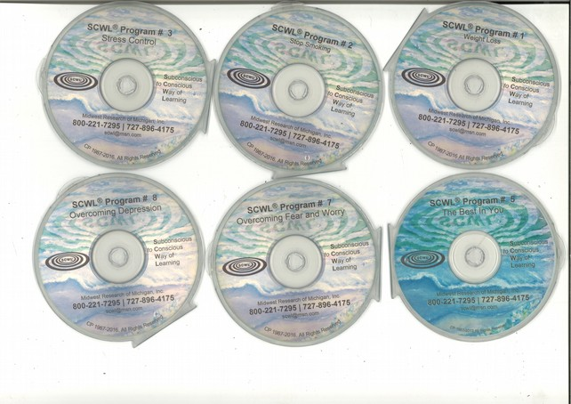
430 Okinawan Karate
437 Astral Projection
450 Alzheimer's
451 Equestrian Riding Program
453 Setting and Achieving Real Estate Goals
454 Organization – Real Estate
455 Telephone Power – Real Estate
456 Referrals – Real Estate
457 Qualifying Buyers – Real Estate
458 Setting Appointments – Real Estate
459 Listing Homes That Sell – Real Estate
460 Closing Real Estate Deals – Real Estate
461 Prospecting for Leads – Real Estate
462 Leadership – Real Estate
463 Attracting Ideal Mates for Women
464 Attracting Ideal Mates for Men
467 Cerebral Palsy (Stage 4)
474 Faith and Victory
475 Health, Life and Spiritual Enrichment
476 Golf - Focusing on the Target
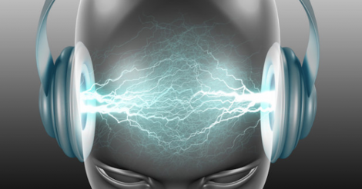
477 Bowling for Higher Average
478 Bowling - Focusing on the Target
479 Managing Insurance Salespeople
480 Recruiting New Agents
481 Total Insurance Success
484 Selling Insurance
487 Healing in the Name of Jesus Christ
491 Competitive Rowing
494 Subliminal Poker
495 Competitive Swimming
496 Running (Elite)
497 Total Control: The Willpower Program
499 Achieving Full Potential in Archery
502 Total Diet Control/Willpower Support Program
503 Competitive Cycling / Training
504 Competitive Cycling / Competition
505 Competitive Cycling / Healing and Recovery
509 The New Testament - KJV
511 I Can Say No to Harmful Drugs
512 Pre Natal Care: Mother & Baby
513 Labour and Delivery
514 Responding to Hypnosis
515 Hockey
517 Shooting Basketball
519 Pearl of Great Price
520 Doctrine and Covenants
523 Attracting Money
526 Achieving the Athletic Zone in Golf
529 Cocaine Abuse
530 New Weight Loss
1095 God's Affirmations
1114 God's Health and Healing
1119 Speak it! Spanish
1120 Speak it! French
1123: For Children under 7: Confidence and Self / Character and Personality / Accelerated Learning
1130 Winning Numbers and Speculation
1151 Breast Enlargement
4127 Mastering Blackjack
*Achieve behavioural change at the subconscious level, without effort, willpower or concentration.
* 180 SCWL titles developed over 41 years.
* New CD selling and purchasing prices in $AU for retailers, resellers and serious users. (US$ is x 75%, e.g. $AU 35 = $US26.25, $AU20 = $US15 etc)

3+ Titles: $35 each (our min. order is 3 titles)
6+ Titles: $30 each = $180+
10+ Titles: $25 each = $250+
15+ Titles: $22.50 each = $337.50+
20+ Titles: $20 each = $400+
30+ Titles: $17.50 each = $525+
50+ Titles: $15 each = $750+
100+ Titles: $12.50 each = $1,250+
* The key to getting the lower prices is to gather orders over say a month from others at intermediate volumes to add up to the lowest price you and they can achieve.
* All programs come with our standard 3 month money back guarantee 'on results'. Our return rate over the past 3 years has been 0.00% indicating the programs have a 100% success rate, providing they are used regularly for results you wish to achieve.
* Currently, postage & handling in Australia is free.
* Payment by transfer to BSB 942207 Account 1516491 and submit your order by phone or email.
* Details for each title: scwl.org/scwlbooklet.doc
* 20 pages of results: scwl.org/testimonies.doc

* Explanatory Videos from the pioneering days:
1a) https://www.youtube.com/watch?v=keddVqLK1bw&t=86s
1b) https://www.youtube.com/watch?v=SrCOH8MqK1U
1c) https://www.youtube.com/watch?v=dS8lJXun6VU
2) https://www.youtube.com/watch?v=YjjvzlLujpQ
3) https://www.youtube.com/watch?v=8fJ8gKWReXM&t=37s
4a) https://www.youtube.com/watch?v=9HHtbnGfPAU&t=2s
4b) https://www.youtube.com/watch?v=f0tO_7VK-iw
5) https://www.youtube.com/watch?v=iQWhF5oUUPE&t=33s

* 25 CD carousel players for sequential play for enhanced compounded results, such as a Pioneer PD-F407, can be found on Google or Ebay and are recommended.
* Why not run off a number of these sheets and ask friends etc to go through the list and see what interests them? In this way you can collectively secure the more price effective free cd offers.
* It can be is daunting to look at the list and try to work out an order. A very effective and easy way to work out your order is to go through the list and circle all the title numbers that interest you whilst at the same time crossing out all those you are definitely not interested in, either for yourself or as gifts, so as to narrow down your selection.
* If you would like the assistance of Doctor David when going through the list to select the titles of interest to you, then please ring me anytime, that is anytime, on 0419 605 365 on your mobile phone for immediate assistance as you go through the list - or even to make an appointment with me to do so in person.
* Orders to: Dr David Murphy, orders@scwl.org, Midwest Research SCWL, Australasia, Est 1984,
Ph (61) 2 9743 4357, 0419 605 365, (61)419 605 365.

