St. Mary Magdalene, Patron Saint of Women

A Biography of the Female Disciple of Jesus
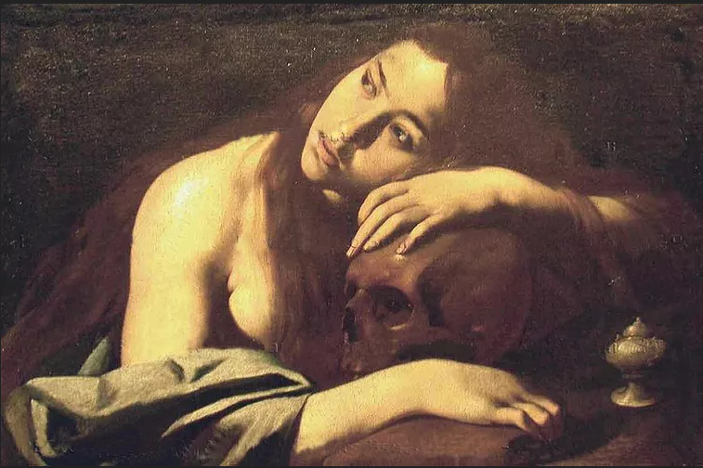
Maestro della Maddalena di Capodimonte [Public domain], via Wikimedia Commons

Christianity
- Catholicism
  - Saints
  - Beliefs and Teachings
  - Prayers
  - Tips
  - Worship
  - Holy Days and Holidays
- Christianity Origins
- The Bible
- The New Testament
- The Old Testament
- Practical Tools for Christians
- Christian Life For Teens
- Christian Prayers

By
Whitney Hopler
Updated on May 12, 2018
St. Mary Magdalene, the patron saint of women, was a close friend and disciple of Jesus Christ who lived during the 1st century in Galilee (then part of the ancient Roman Empire and now part of Israel). Saint Mary Magdalene is one of the most famous women of the Bible. She was dramatically transformed during her life from a person who was possessed by demons to someone who became a close friend of the person whom Christians believe was God himself.

Feast Day: July 22nd

Patron Saint Of
St. Mary Magdalene is that patron saint of women, converts to Christianity, people who enjoy contemplating God's mysteries, people who are persecuted for their piety, people who are penitent about their sins, people who struggle with sexual temptation, apothecaries, glove makers, hairdressers, perfume makers, pharmacists, reformed prostitutes, tanners, and various places and churches worldwide.

Eyewitness to the Crucifixion and Resurrection
Mary Magdalene is most famous for being an eyewitness to the most important miracles of the Christian faith: Jesus Christ's death on the cross.
Mary was one of a group of people present as Jesus was crucified, and she was the first person to encounter Jesus after his resurrection, the Bible says. declares John 19:25 when describing the crucifixion.
Mark 16:9-10 mentions that Mary was the first human being to see the resurrected Jesus on the first Easter:
"When Jesus rose early on the first day of the week, he appeared first to Mary Magdalene, out of whom he had driven seven demons. She went and told those who had been with him and who were mourning and weeping."

A Miraculous Healing
Before meeting Jesus, Mary had suffered both spiritually and physically from evil that was tormenting her. Luke 9:1-3 mentions that Jesus had healed Mary by exorcising seven demons from her, and describes how she had then joined a group of people following Jesus and supporting his ministry work:
"...Jesus traveled about from one town and village to another, proclaiming the good news of the kingdom of God. The Twelve [disciples] were with him, and also some women who had been cured of evil spirits and diseases: Mary (called Magdalene) from whom seven demons had come out; Joanna the wife of Chuza, the manager of Herod's household; Susanna; and many others. These women were helping to support them out of their own means."

Easter Egg Miracle
The tradition of using eggs to celebrate Easter began soon after Jesus was resurrected since eggs were already a natural symbol of new life. Often, ancient Christians would hold eggs in their hands as they proclaimed "Christ is risen!" to people on Easter.
Christian tradition says that when Mary met the Roman emperor Tiberius Caesar at a banquet, she held up a plain egg and told him: "Christ is risen!". The emperor laughed and told Mary that the idea of Jesus Christ rising from the dead was as unlikely as the egg she held turning red in her hands. But the egg did turn a bright shade of red while Tiberius Caesar was still speaking. That miracle caught the attention of everyone at the banquet, which gave Mary the opportunity to share the Gospel message with everyone there.

Miraculous Help from Angels
During the later years of her life, Mary lived in a cave called Sainte-Baume in France, so she could spend most of her time in spiritual contemplation. Tradition says that angels came to her every day to give her Communion in the cave and that angels miraculously transported her from the cave to the chapel of St. Maximin, where she received the last sacraments from a priest before dying at age 72.

Biography
History hasn't preserved information about Mary Magdalene's life prior to the time in her adulthood when she met Jesus Christ and needed his help. The Bible records that Mary (whose last name derives from the fact that her hometown was Magdala in Galilee in modern Israel) suffered in both body and soul from seven demons who had possessed her, but then Jesus exorcised the demons and healed Mary.
Catholic tradition suggests that Mary may have worked as a prostitute prior to her encounter with Jesus. This led to the establishment of charitable homes called "Magdalene houses" that help women break free of prostitution.
Mary became part of a group of both men and women who were devoted to following Jesus Christ and sharing his Gospel (which means "good news") message. She showed natural leadership qualities and became the best-known woman from among Jesus' disciples because of her work as a leader in the early church. Several non-canonical texts from the Jewish and Christian Apocrypha and Gnostic gospels say that Jesus loved Mary the most out of all his disciples, and in popular culture, some people have extrapolated that to mean that Mary may have been Jesus' wife. But there's no evidence from either religious or historical texts that Mary was anything more than Jesus' friend and disciple, as were other many men and women who had met him.
When Jesus was crucified, the Bible says, Mary was among a group of women watching near the cross. After his death, Mary went to the tomb carrying spices that she and other women had prepared to anoint his body (a Jewish custom to honor someone who has died). But when Mary arrived, she encountered angels who told her that Jesus had risen from the dead and she became the first person to see Jesus after his resurrection.
Many religious texts state that Mary was devoted to sharing the Gospel message with many people after Jesus ascended to heaven. But it's unclear where she spent her later years. One tradition says that about 14 years after Jesus ascended to heaven, Mary and a group of other early Christians were forced by Jews who had persecuted them to get into a boat and set out to sea without sails or oars. The group landed in southern France, and Mary lived the rest of her life in a nearby cave contemplating spiritual matters. Another tradition says that Mary traveled with the apostle John to Ephesus (in modern Turkey) and retired there.
Mary has become one of the most celebrated of all Jesus' disciples. Pope Benedict XVI has said about her:
"The story of Mary of Magdala reminds us all of a fundamental truth. A disciple of Christ is one who, in the experience of human weakness, has had the humility to ask for his help, has been healed by him and has set out following closely after him, becoming a witness of the power of his merciful love that is stronger than sin and death."

