Wipeout Page

Some amazing signs, portents and proofs to ponder in our Murf the Surf Wipeout murfari surfari.

Wipeout Tune on Youtube. At the beginning you will hear what sounds like the ground cracking under me as I fell in the subterranean fire that morning at 9.05 am.

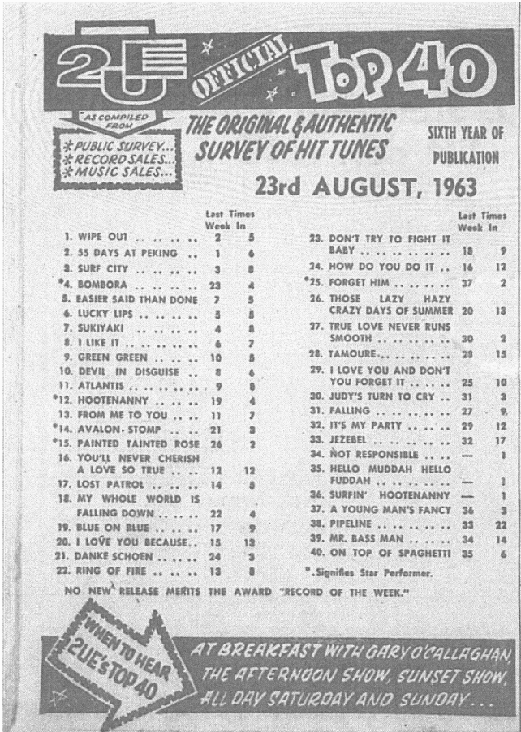
Wipeout, by the Surfaris, hit number 1 on the 2UE Top 40 on the very morning of the accident (23.8.63) at Bressington Park, Homebush Bay, showing that a many faceted Wipeout facility would eventually develop from my personal wipeout, at age 9, that morning.

Also please check out:

#2: “55 Days at Peking”, by Rob E G, the number of days between 23.4, (see Bombora) when Comer came to have me breach my Terms on behalf of his instructing clients, and 18.6.90, the date of the Deed, 55 days at peeking in between. A CoronaLien portent prophecy yet to come?

#4: “Bombora”, by the Atlantics – a long slow running wave which can't be seen from the surface as it goes by but which swamps the beach when it breaks as on 23.4.1990.

#13: “From Me To You”, The first Beatles song to ever hit the Top 40 announcing how the money travels from me to you when we do a Debt Wipeout.

#22 “Ring of Fire” by Johnny Cash – “I fell into a burning ring of fire.”

and

#34 The highest newcomer in the chart, at the number of the house in which I grew up, announced that I was “Not Responsible”, by Helen Shapiro, not at fault.

Two other notable songs are #18 “My Whole World is Falling Down” by Brenda Lee and #31 “Falling” by Roy Orbison.

Here are some other charts of dates significant in the matter:

