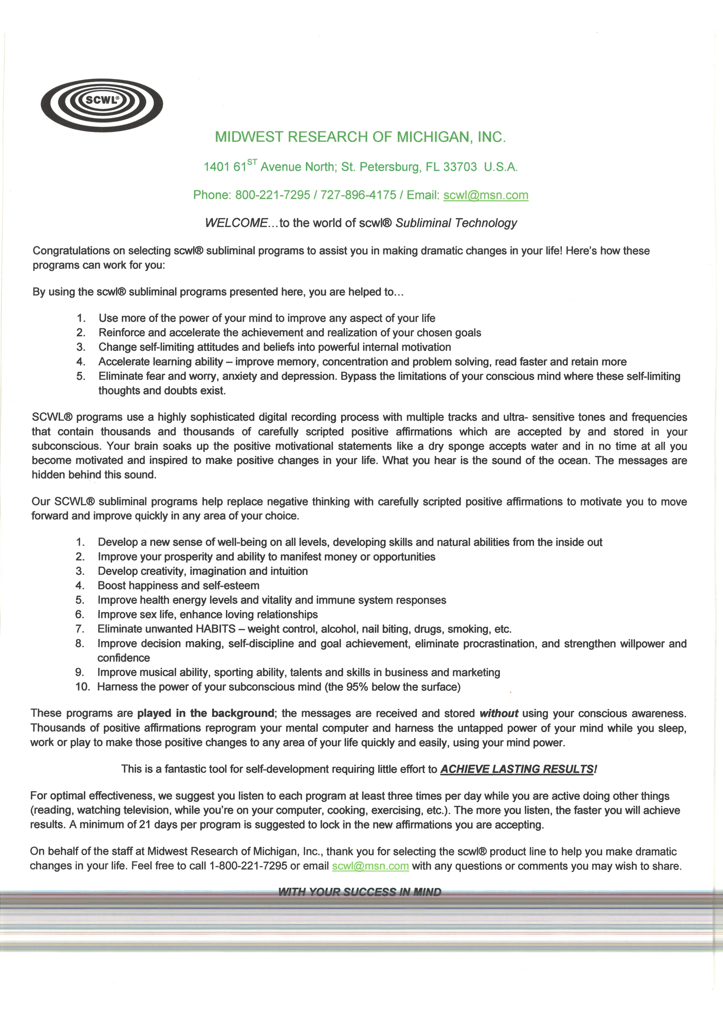

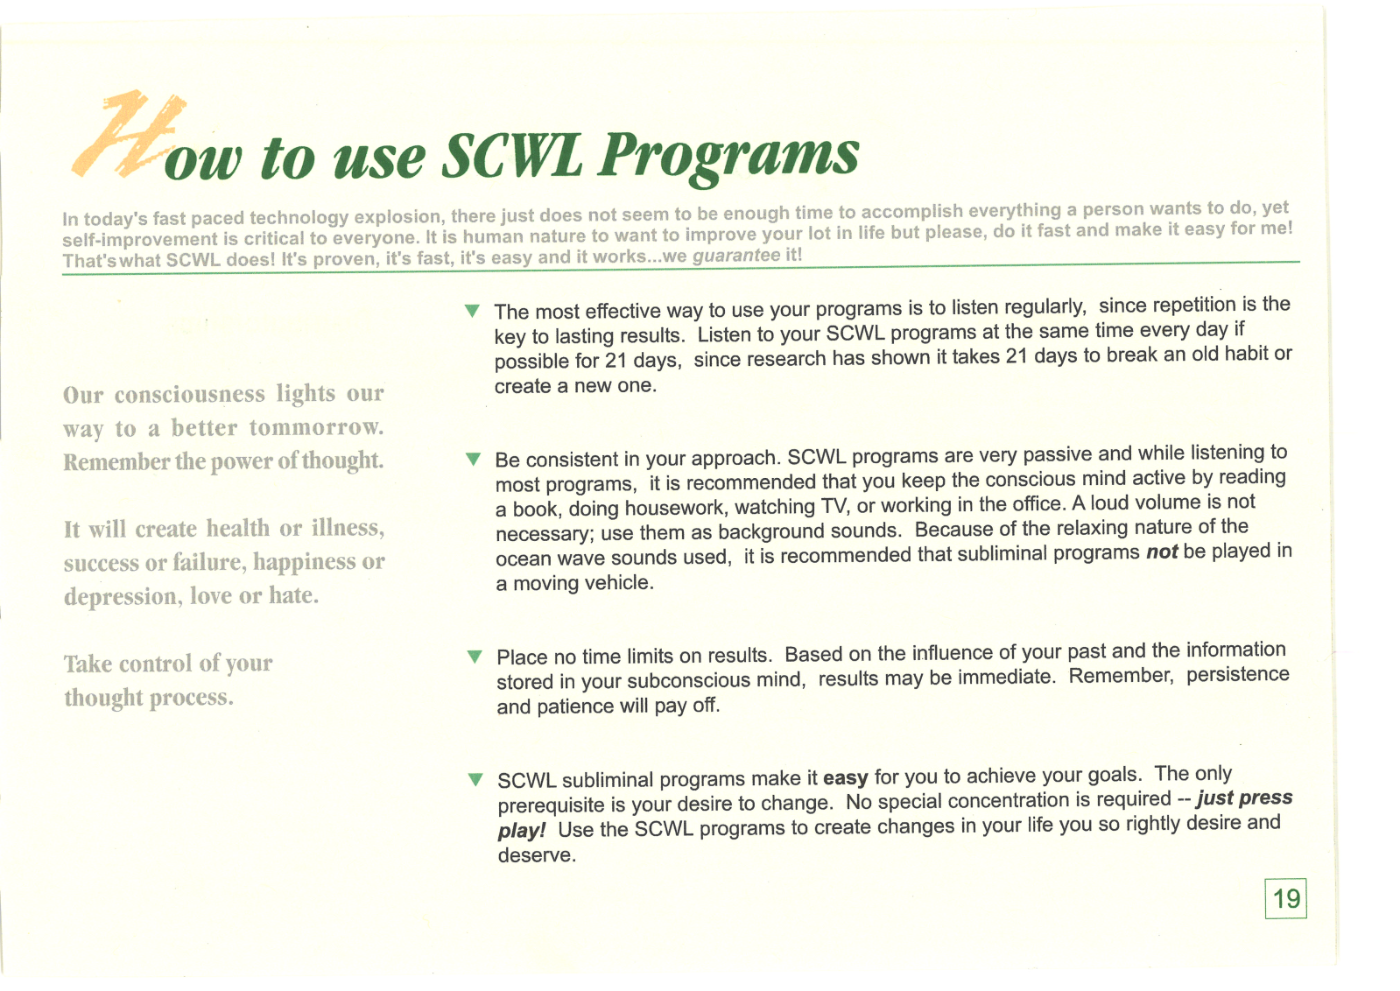
With the take up of subliminal reprogramming much money can be saved which is now being expended and priorities reassessed. In fact I note from my now 30 years of experience in this intervention drug therapy to be like dealing with a blunt and outdated hit and miss analog approach and subliminal digital reprogramming to be like operating on the subconscious mind with a sharp incisive instrument to excise undesirable conditioning and traits with far less incidence of side effects where a final solution may in many cases be achieved in place of endless palliative care under the care of therapists who note steady progress to optimization. A far cry to what is happening now.
A surgeon would not use a blunt knife to achieve top results in a delicate and critical operation or a knife that had been fouled up with germs. The sharper the sculptor's tool the finer the result and the more excellence that can be achieved. So it is with carving out the old conditioning and carving in the new so to speak. Resculpt the organic storage material by way of a soundblasting electrical nerve impulse knife to refashion the organic material that holds the conditioning and obtain a newer and preferred output designer result that changes lives for the good permanently once the new learned responses and conditioning are put into action.
Subliminals work by impacting and refashioning previous long standing hard core conditioning which may by its very nature be impervious to drugs and conscious addressing. Undesirable conditioning has generally entered by way of nerve impulses arising from sounds, sight and touch over a life time and are stored chemically in the brain and nervous system and as such undesirable programming needs to be addressed again by way of engineered electrical nerve impulses to refashion by design the organic media in which they are now resident. By reprogramming people improperly programmed due to previous inputs you can alter their lives for the better in away the drugs clearly cannot.
Researched subliminals are a way of reprogramming the computer of the brain to elicit altered responses when areas where conditioning are stored is addressed. Re engineer the resident programming and you gain a different response providing the client is desirous.
Subliminal reprogramming postulates that in many, not all but in many, cases conditioning and programming give rise to responses resident in the subconscious mind, organically stored, and if we rewrite organically stored conditioning by way of repeatedly impacting by way of electronic nerved impulses at a variety of frequencies and speeds in a fashion that cannot consciously be deflected and rejected we bypass the analytical processes of the conscious mind and we can alter responses and outlook in a much more modern and cost effective manner. Most conditioning in the mind is verbal or visual and is the continual rerunning of programs resident there. Access and rewrite that programming with a digital instrument and new responses come into evidence and lead to altered behaviours and enhanced skills by way of changing past undesirable learnings and response patterns. Without resculpting the resident conditioning long laid down much change cannot be achieved. Drugs of course cannot do it as the past 100 years or so have shown and many only suppress some responses but do not optimize. They are a blunt liquid instrument not a digital impacting resculpting instrument.
In my time with Midwest I noted the return rate was less than 3% with a 104 day money back guarantee. If the Midwest Research subliminals gave only a 30%-35% placebo effect the return rate would be more than 10 times higher so as to make the business where I served for 13 years unviable. The return rate points to unchallenged efficacy in a 13 year market litmus test here in Australia and a 97% retention rate tends to prove that in the 1990's audio subliminals by that one research company worked and gave satisfying results. If some people chose not to return and the true non performance rate was three times higher we still have a satisfaction rate of 91%. If delivery and purchase was attended by attending a seminar on their use and the consumers were educated, as by one major international seminar provider whom I supplied for many years, the return rate was shown to be zero.

